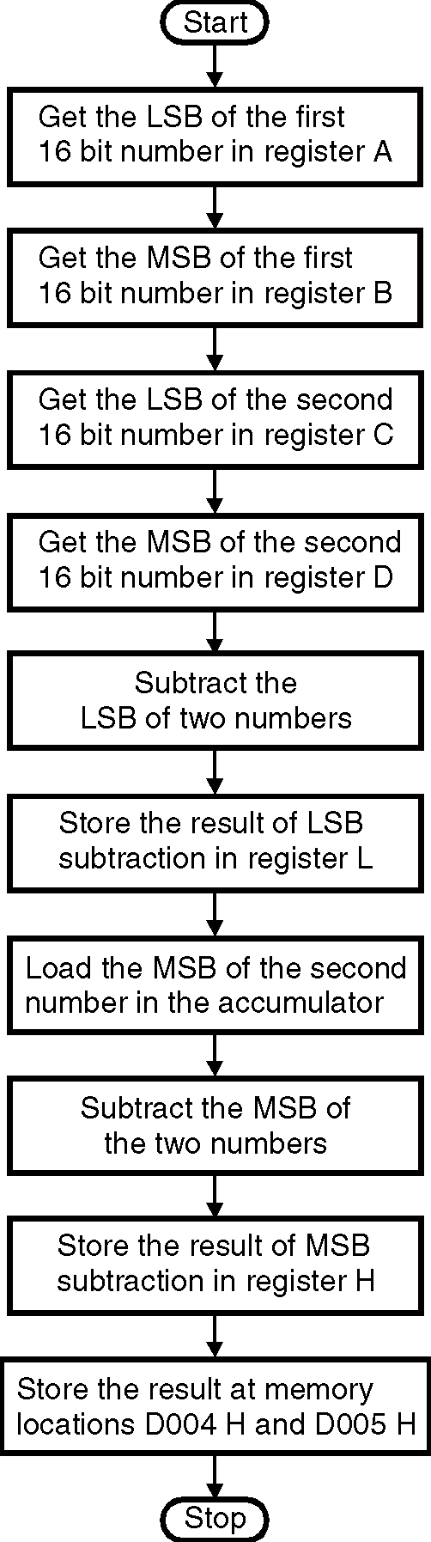
➢➢ Explanation :
- We are given two 16 bit numbers at memory locations D000 H, D001 H and D002 H, D003 H. Let these numbers be 1234 H and 0100 H.
- We have to subtract the word at memory locations D000 H and D001 H (1234 H) from the word at memory locations D002 H and D003 H (0100 H).
- We subtract the two LSBs and the two MSB separately.
- Store the result at memory locations D004 H and D005 H.
➢➢ Algorithm :
Step I : Start
Step II : Get the LSB of first 16 bit number in A.
Step III : Get the MSB of the first number in register B.
Step IV : Get the LSB of the second number in register C
Step V : Get the MSB of the second number in register D
Step VI : Subtract the LSB of two numbers.
Step VII : Store the result of LSB subtraction
in register L.
Step VIII : Load the MSB of the first number in accumulator.
Step IX : Subtract the MSB of two numbers.
Step X : Store the result of MSB subtraction
in register H.
Step XI : Store the result at memory locations
D004 H and D005 H.
Step XII : Stop.
➢➢ Flowchart : Refer flowchart 8.
➢➢ Program 1 :
Instruction Comment
LXI H, D000 H ; HL points to the memory
; location D000 H
MOV A, M ; Get the contents of location
; D000 H into the accumulator.
INX H ; Increment HL to point to next
; memory location i.e. D001H Flowchart 8
MOV B, M ; Get the contents D001 H into register B i.e. MSB of first number.
INX H ; Increment HL to point to next memory location i.e. D002H
MOV C, M ; Get the contents D002 H into register C i.e. LSB of 2nd number.
INX H ; Increment HL to point to next memory location i.e. D003H
MOV D, M ; Get the contents D003 H into register C i.e. MSB of 2nd number.
SUB C ; Compute LSB subtraction A= A – C
MOV L, A ; Store the result in register L.
MOV A, B ; Copy the contents of MSB of first number to the accumulator.
SUB D ; Compute MSB subtraction A= A – D
MOV H, A ; Store the result in register H.
SHLD 2004 H ; Store the result at memory locations 2004 H and 2005 H.
HLT

